|  |  |  |
| --- | --- | --- |
| https://upload.wikimedia.org/wikipedia/commons/thumb/4/4e/VU_Logo.png/260px-VU_Logo.png | Computer Architecture and Assembly Language Programming (CS401)  Assignment No. 3 | Total marks = 20  Deadline Date:  July 15, 2021 |

Solution

NAME: TAMKEEN SAJJAD

ID: MC200400003

Course: MIT

**Submission:**

1. Complete assembly language program.

org 0x100

xor ax, ax

mov es, ax

cli ; update ISR address w/ ints disabled

push word [es:9*4+2] ; preserve ISR address

push word [es:9*4]

mov word [es:9*4], irq1isr

mov [es:9*4+2],cs

sti

call test0

cli ; update ISR address w/ ints disabled

pop word [es:9*4] ; restore ISR address

pop word [es:9*4+2]

sti

;;;;;;;;;;;;;;;;;;;;;;;;;;;;;;;;;;;;;;;;;

;;;;;;;;check the enter key ;;;;;;;;;;;;;

;;;;;;;;;;;;;;;;;;;;;;;;;;;;;;;;;;;;;;;;;

l1: mov ah, 0 ; service 0 – get keystroke

int 0x16 ; call BIOS keyboard service

cmp al, 13 ; is the ENTER key pressed

jne l1 ; if no, check for next key

mov ax, 0x4c00 ; terminate program

int 0x21

;;;;;;;;;;;;;;;;;;;;;;;;;;;;;;;;;;;;;;;;;

ret

test0:

mov ah, 9

mov dx, msg1

int 0x21 ; print "Press and hold SPACE"

test1:

mov al, [kbdbuf + 39H] ; check SPACE key state (SPACE scan code = 39H)

or al, al

jz test1 ; wait until it's nonzero (pressed/held)

mov dx, msg2

;;;;;;;;;;;;;;;;;;;;;;;;;;;;;;;;;;;;;;;;;

;;;;Color the first half as Blue;;;;;;;;;

;;;;;;;;;;;;;;;;;;;;;;;;;;;;;;;;;;;;;;;;;

MOV AH, 06h ; Scroll up function

XOR AL, AL ; Clear entire screen

XOR CX, CX ; Upper left corner CH=row, CL=column

MOV DX, 1827H ; lower right corner DH=row, DL=column

MOV BH, 1Eh ; YellowOnBlue

INT 10H

;;;;;;;;;;;;;;;;;;;;;;;;;;;;;;;;;;;;;;;;;

int 0x21 ; print "SPACE pressed, release SPACE"

test2:

mov al, [kbdbuf + 39H] ; check SPACE key state (SPACE scan code = 39H)

or al, al

jnz test2 ; wait until it's zero (released/not pressed)

mov dx, msg3 ; print "SPACE released"

;;;;;;;;;;;;;;;;;;;;;;;;;;;;;;;;;;;;;;;;;

;;;;Color the 2nd half as green ;;;;;;;;;

;;;;;;;;;;;;;;;;;;;;;;;;;;;;;;;;;;;;;;;;;

XOR CX, 0028H ; Upper left corner CH=row, CL=column

MOV DX, 184FH ; lower right corner DH=row, DL=column

MOV BH, 28h ; YellowOnBlue

INT 10H

;;;;;;;;;;;;;;;;;;;;;;;;;;;;;;;;;;;;;;;;;

int 0x21

ret

irq1isr:

pusha

; read keyboard scan code

in al, 0x60

; update keyboard state

xor bh, bh

mov bl, al

and bl, 0x7F ; bx = scan code

shr al, 7 ; al = 0 if pressed, 1 if released

xor al, 1 ; al = 1 if pressed, 0 if released

mov [cs:bx+kbdbuf], al

; send EOI to XT keyboard

in al, 0x61

mov ah, al

or al, 0x80

out 0x61, al

mov al, ah

out 0x61, al

; send EOI to master PIC

mov al, 0x20

out 0x20, al

popa

iret

kbdbuf:

times 128 db 0

msg1 db "Press and hold SPACE", 13, 10, "$"

msg2 db "SPACE pressed, release SPACE", 13, 10, "$"

msg3 db "SPACE released", 13, 10, "$"

1. Screenshot of the compilation step.

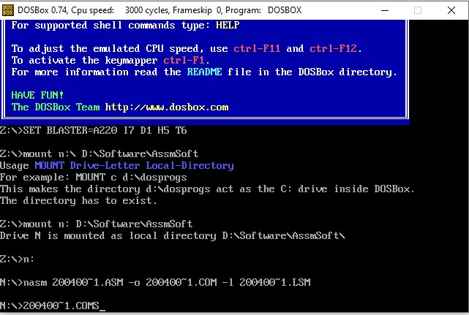

1. Screenshot of the final output.

